
Keeping yourself safe at home and when you are out in public spaces





- Answering the door
Page 3

- Checking Identification (ID)
Page 5
- When to call 999
Page 7

- When talking to the Police
Page 8

Answering the door

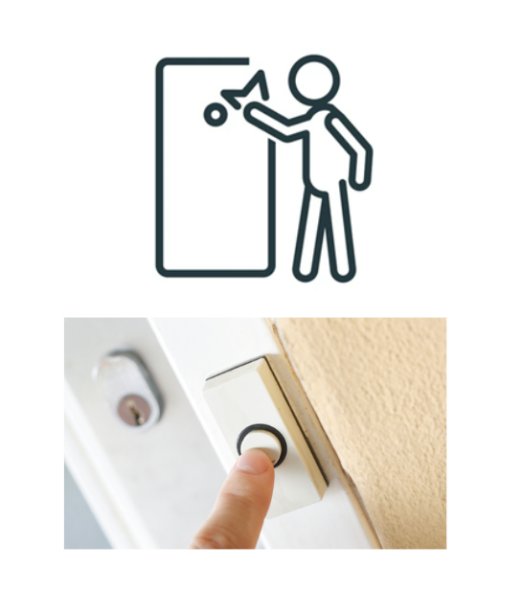 | Keep the door closed while you check who is outside your door.  They may knock on the door or ring the doorbell.
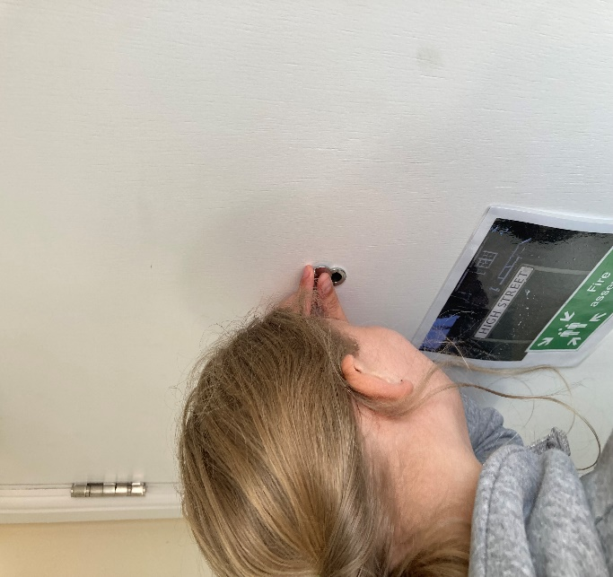 | If you have a spy hole, look through it.
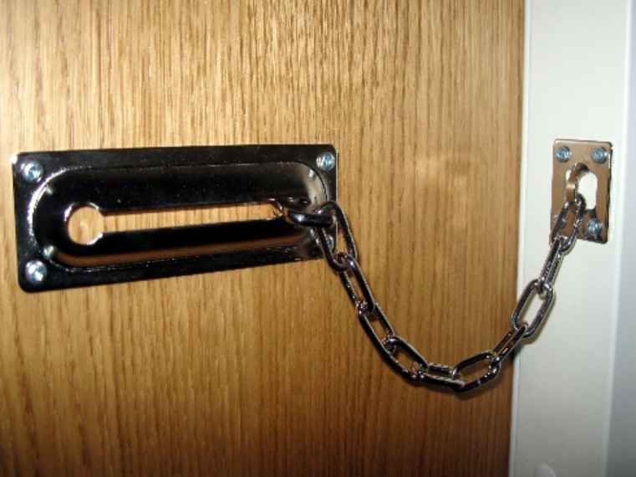 | If you have a door chain, keep it connected while you open the door and check who is there.
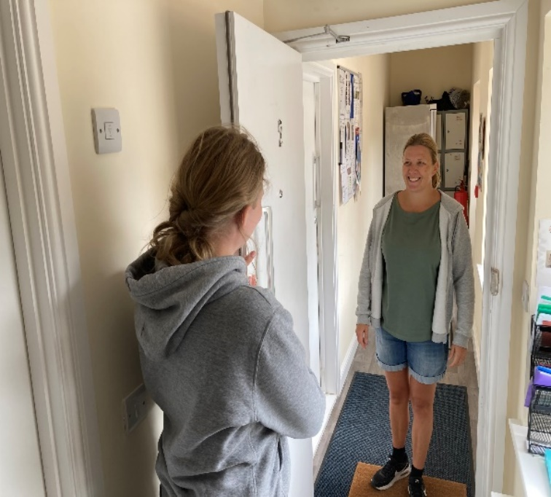 | If you are happy for them to come in, welcome them in.

Checking Identification (ID)

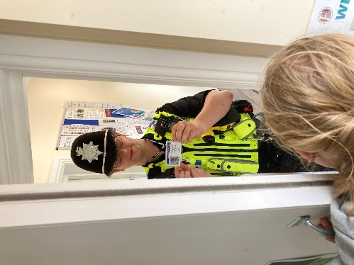 | If you do not know them and they need to come into your home, always ask for their ID.
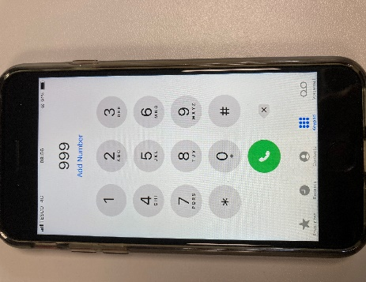 | If they do not show you their ID, please call 999.
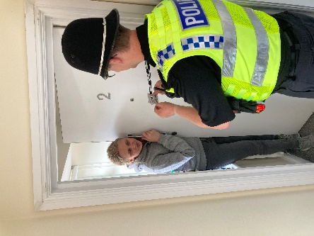 | When you have their ID, check it looks like them.  If you are worried, please call 999.
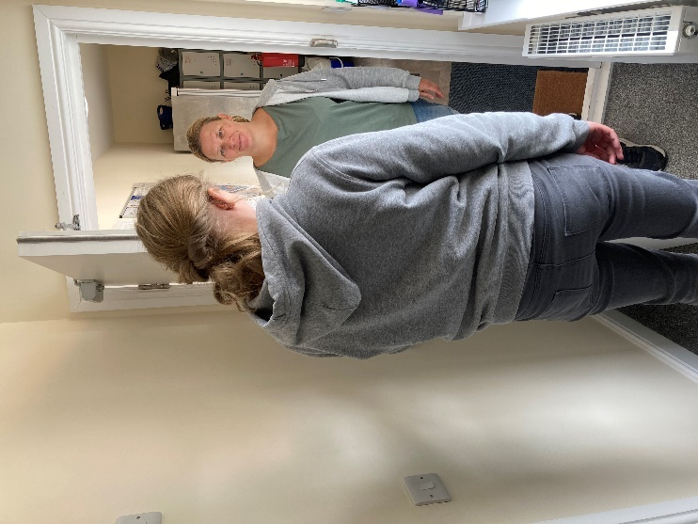 | If you are expecting a visitor and you are OK for them to come into your home, let them in.
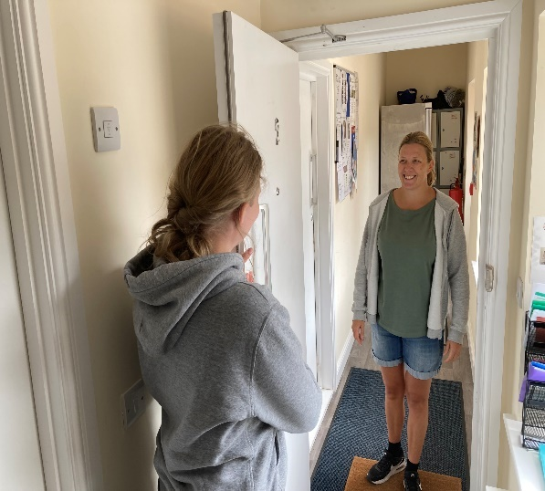 | If it is a trusted adult that you know, you don’t need to see their ID.  Welcome them in.

When to call 999
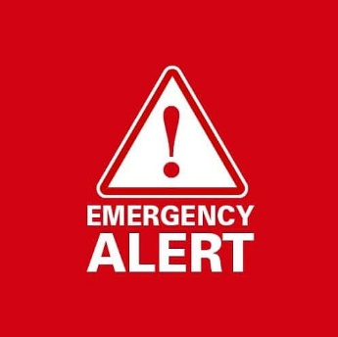 | An emergency is when a crime is taking place, or someone is in danger.
 | If there is an emergency, call 999.
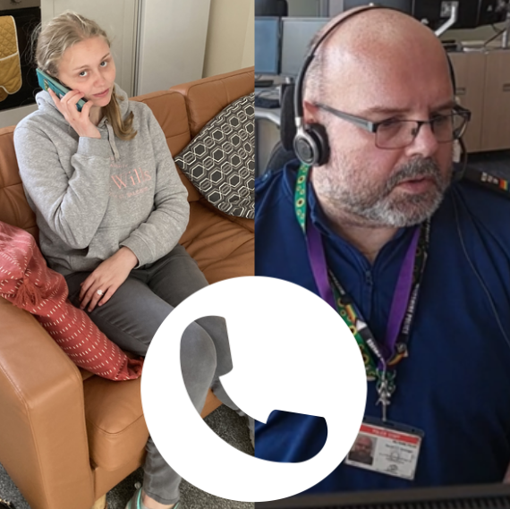 | The person on the phone will ask you some questions. They will ask:  - What happened?  - Where did it happen?  - When did it happen?

When talking to the Police

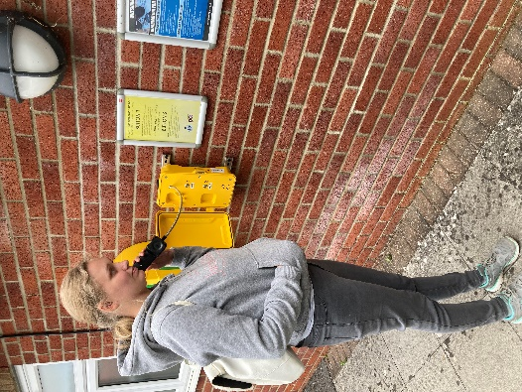 | There will be a yellow box with a direct telephone line to the Police at your nearest Police Station.
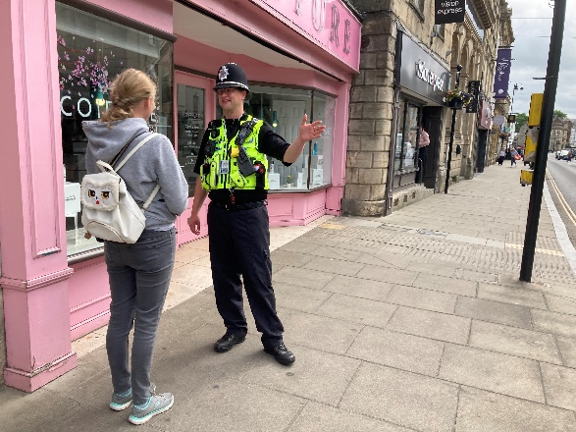 | If you are lost, feel unsafe, or need directions, the Police will always be able to help.
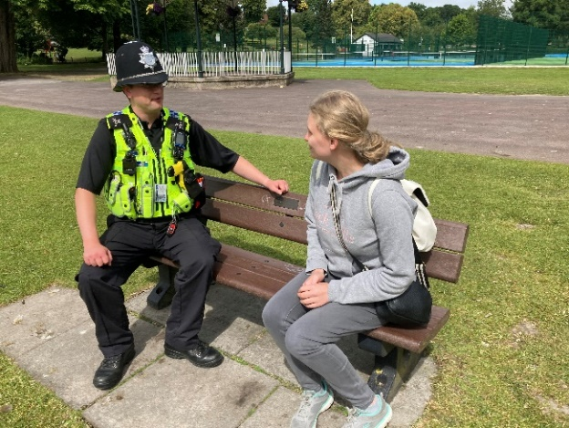 | The Police can talk to you in a space you are comfortable with – like a park you know if you are out in public.
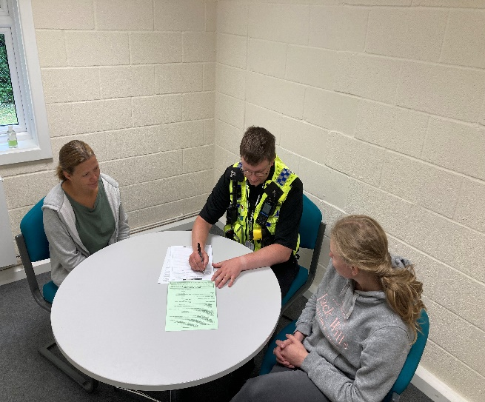 | If you see a crime, the police may need to write down what you saw and heard.  This is called a statement.  You can do this at a Police Station or an officer will come to your home.  Always be with a trusted adult.
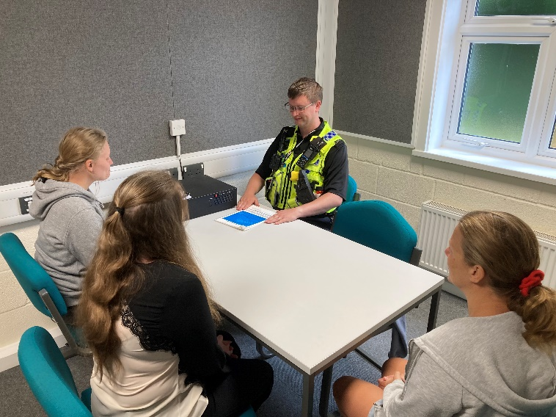 | If the Police need to interview you for an offence (a crime), you will be with an adult you trust and a solicitor.
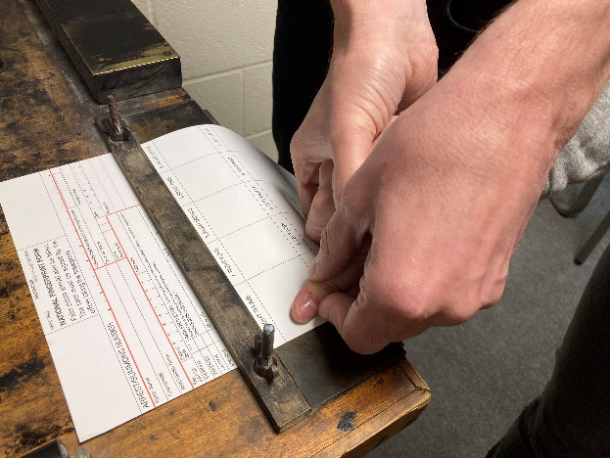 | If the Police take your fingerprints, they will either do it using an inkpad or computer system.

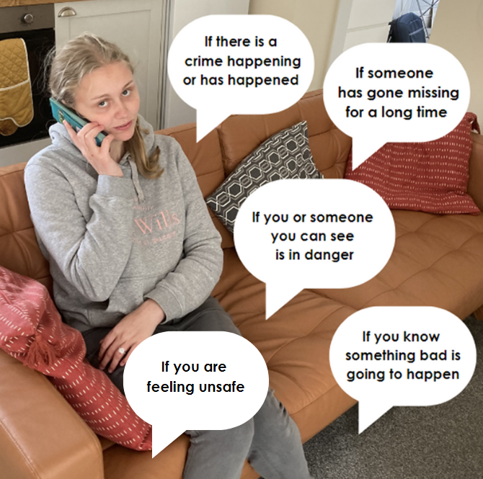
Remember, you can always call the Police on 999 in an emergency. Here are some examples…

You can also call the Police on 101 when it is not an emergency.

